Example 1: Solve the system of linear equations by substitution
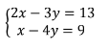

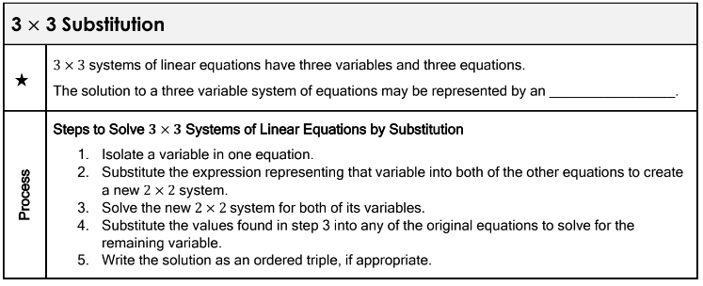

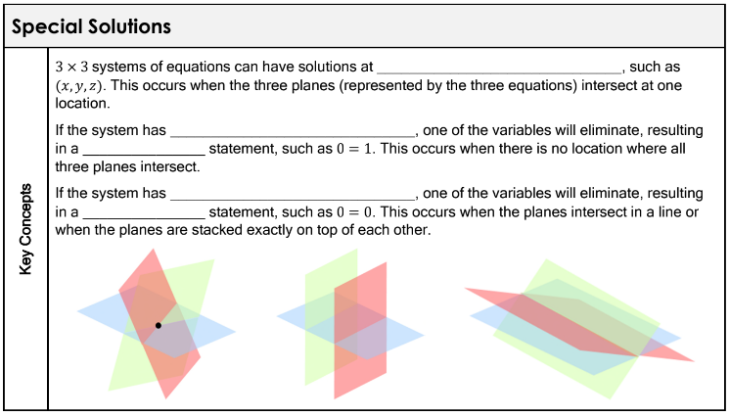

Example 2: Solve the system of linear equations by substitution
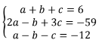

Example 3: Solve the system of linear equations by substitution
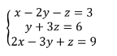

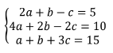
Example 4: Solve the system of linear equations by substitution

